UI Design and Prototyping Report- E-commerce site

IIITRanchi Shopping Site

## 1. Introduction

* This is a bootstrap4 based project of E-commerce Site made for the Institute IIIT Ranchi to provide their students a portal to make purchase of college hoddies and essential study related items at Institute Sponsored Prices.

## 2. User Interface Design and Prototype

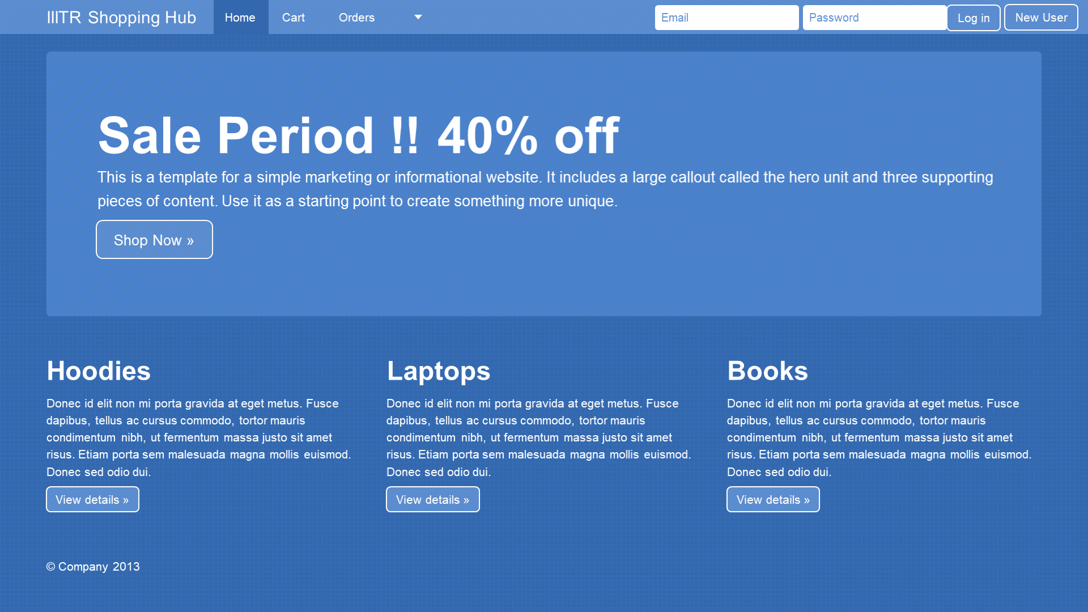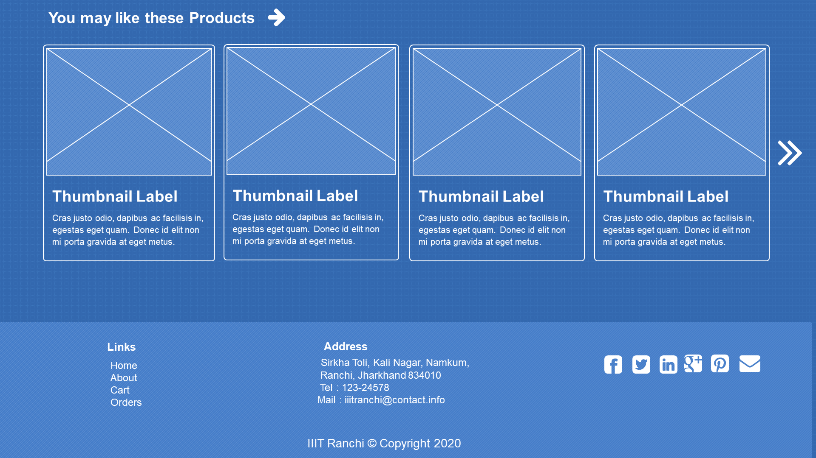

* Our Portal will have a Home page , cart/order section so that the user can keep track of items and it will also have login/registration section.

## 3. Navigation Structure

* Cart button – takes the user to cart section
* Orders – Takes the user to orders section where user can see details of all the orders placed in near history.
* Login button will start the session
* New user button- Takes you to the registration page
* View details button will take you to single categories pages

## 4. References

* <https://onextrapixel.com/free-bootstrap-wireframing-set-for-powerpoint/>
* <https://www.coursera.org/learn/bootstrap-4/supplement/ughzX/ui-design-and-prototyping-report-template>